**William Alfred Higinbotham**

William Alfred Higinbotham (October 22, 1910 – November 10, 1994) was an American physicist. Was head of Instrumentation at Brookhaven National Laboratory. First chairman and Secretary of FAS.

https://physicstoday.scitation.org/do/10.1063/PT.6.6.20171025a/full

After witnessing the Trinity test up close and the destruction in Hiroshima and Nagasaki from afar, Higinbotham became dedicated to limiting the production and spread of nuclear weapons. He was instrumental in transforming the Federation of Atomic Scientists(FAS), whose membership was made up of Manhattan Project scientists, into the Federation of American Scientists, whose membership was open to all scientists.



**Morton Grodzins**

Morton M. Grodzins (1917–64), Professor of political science at the University of Chicago.

<https://encyclopedia.densho.org/Morton_Grodzins/>

[apf1-06566r.jpg (1000×800) (uchicago.edu)](https://storage.lib.uchicago.edu/ucpa/series1/derivatives_series1/apf1-06566r.jpg)

His major outside contribution came in the field of science and arms control. In 1957 Grodzins joined the editorial board of the Bulletin of Atomic Scientists (for which his wife served as administrator) and in 1963 coedited The Atomic Age, an anthology of papers from the Bulletin. He played a leading role in the annual Pugwash Conferences on Science and World Affairs.



**Linus Carl Pauling**

Linus Carl Pauling was an American chemist, biochemist, chemical engineer, peace activist, author, and educator.

https://www.nobelprize.org/prizes/chemistry/1954/pauling/facts/

1962 Prize: The atom bombs dropped on Hiroshima and Nagasaki were a turning point in Linus Pauling's life. Together with other scientists he spoke and wrote against the nuclear arms race, and he was a driving force in the Pugwash movement. It sought to reduce the role of nuclear arms in international politics and was awarded the Peace Prize in 1995.



**Aleksandr P. Vinogradov**

Aleksandr P Vinogradov, geochemist andpresident of the Soviet Academy of Sciences and head of Moscow's Institute of Geochemistry and Analytical Chemistry until his death

Since 1958, he has been a member of the international Pugwash Conference of Peace Scientists. Elected a member of a number of foreign academies of sciences; honorary member of the American and French Geological Societies; Honorary President of the International Association of Geochemistry and Cosmochemistry

[https://www.nytimes.com/1975/11/19/archives/ap-vinogradov-80-soviet-geochemist.html](https://www.nytimes.com/1975/11/19/archives/ap-vinogradov-80-soviet-geochemist.ht)

https://donschool86.ru/en/communion/vinogradov-geohimiya-aleksandr-pavlovich-vinogradov-biografiya-osnovnye.html

Wrote the article “Prospects for the Pugwash Movement.”

Bulletin of the Atomic Scientists 15 (November 1959): 376-378.

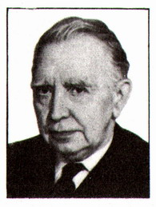

**Alexander M. Kuzin (Александр М. Кузин, May 17 (30), 1906 - July 26, 1999)**

Aleksandr Mikhailovich Kuzin - Soviet biophysicist and radiobiologist. Corresponding Member of the USSR Academy of Sciences (1960). Member of the CPSU since 1946.

https://ru.wikipedia.org/wiki/%D0%9A%D1%83%D0%B7%D0%B8%D0%BD,_%D0%90%D0%BB%D0%B5%D0%BA%D1%81%D0%B0%D0%BD%D0%B4%D1%80_%D0%9C%D0%B8%D1%85%D0%B0%D0%B9%D0%BB%D0%BE%D0%B2%D0%B8%D1%87

Referenced in “Making weapons, talking peace: a physicist's odyssey from Hiroshima to Geneva”, By Herbert F. York · 1987



**Marcus Laurence Elwin Oliphant 1901-2000**

Marcus Laurence Elwin Oliphant, Poynting Professor of Physics at the University of Birmingham, First President of the Australian Academy of Science, Australia

The bombings of Hiroshima and Nagasaki “left Oliphant with a burden of guilt that ever after affected his public life and work.”[28] He became highly critical of nuclear weapons, promoted international nuclear weapons control and joined the Pugwash Movement. [29]

https://www.atomicheritage.org/history/making-jitterbug-work-marcus-oliphant-and-manhattan-project

<https://www.atomicheritage.org/profile/mark-oliphant>



**Charles Galton Darwin (18 December 1887 – 31 December 1962)**

Charles Galton was a physicist who served as director of the National Physical Laboratory (NPL) during the Second World War.[2] Sir Charles Galton Darwin was appointed director of the Central Scientific Office in Washington in 1941.

[Charles Galton Darwin, 1887-1962 (royalsocietypublishing.org)](https://royalsocietypublishing.org/doi/pdf/10.1098/rsbm.1963.0004)

[SPC_report_Inside_RS1619_Science diplomacy _Jan10.indd (aaas.org)](https://www.aaas.org/sites/default/files/New_Frontiers.pdf)

He was one of those concerned in liaison with the United States of America over the atomic bomb. He was told the details of the work of the MAUD Committee on the bomb and was sent a copy of its report. He was one of the very few scientists at this early date to realize that the use of an atomic bomb was a problem different in kind, as well as in explosive power, from conventional weapons.

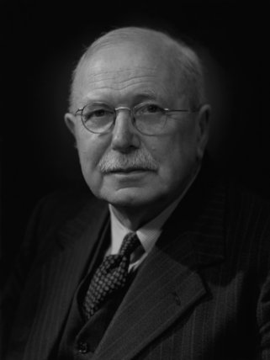

**Howard Franklyn Skidmore (September 24, 1917 ~ March 4, 2008)**

Howard Franklyn Skidmore, newspaperman and public relations counsel. Howard served as special assistant to C & O's chairman, Cyrus S. Eaton.

[Howard Franklyn Skidmore Obituary (2008) - Carmel, CA - Monterey Herald (legacy.com)](https://www.legacy.com/us/obituaries/montereyherald/name/howard-franklyn-skidmore-obituary?id=23979413)

Wife [Zaza Skidmore Obituary (2012) - CARMEL, CA - Monterey Herald (legacy.com)](https://www.legacy.com/us/obituaries/montereyherald/name/zaza-skidmore-obituary?id=19929343)

**Jerome Bert Wiesner (30 May 1915-21 October 1994)**

Jerome Bert Wiesner was a professor of electrical engineering at MIT. In 1961, chosen by President John F. Kennedy as chairman of his Science Advisory Committee (PSAC). President of the Massachusetts Institute of Technology from 1971 to 1980.

<https://libraries.mit.edu/mithistory/institute/offices/office-of-the-mit-president/jerome-bert-wiesner-1915-1994/>

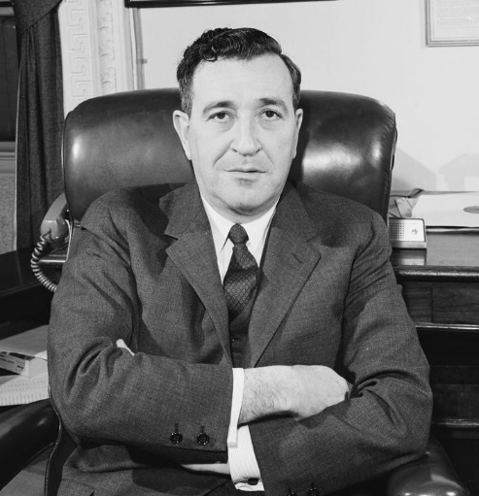

**John Tileston Edsall (3 November 1902 – 12 June 2002)**

John T. Edsall: Biochemist, Teacher, Journal of Biological Chemistry Editor, and Responsible Scientist

[**https://www.jbc.org/article/S0021-9258(18)75587-7/fulltext**](https://www.jbc.org/article/S0021-9258(18)75587-7/fulltext)

Edsall played an important role also in the establishment of the Committee on Scientific Freedom and Responsibility (CSFR) of the American Association for Advancement of Science (AAAS).

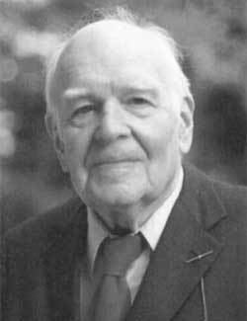

Leo Szilard (1898-1964)

 Leo Szilard was a Hungarian-American physicist and inventor who developed the idea of the nuclear chain reaction in 1933.

<https://www.atomicheritage.org/history/leo-szilards-fight-stop-bomb>

Szilard received the Atoms for Peace Award in 1959, and was named Humanist of the Year by the American Humanist Association, and given the Albert Einstein Award in 1960. In 1962, he founded the Council for a Livable World, an organization dedicated to delivering “the sweet voice of reason” about nuclear weapons to Congress, the White House, and the American public.

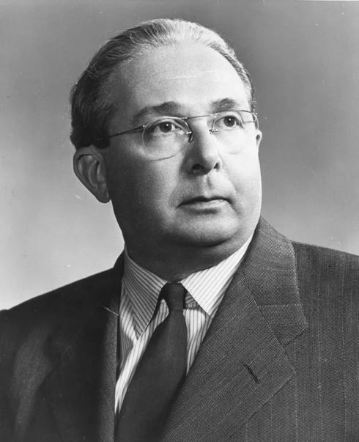

**Cyrus Stephen Eaton Sr.** **(December 27, 1883 – May 9, 1979)**

Cyrus Stephen Eaton Sr**.** was a Cleveland-based Canadian-American investment banker, businessman and philanthropist,

[Cyrus S. Eaton - Wikipedia](https://en.wikipedia.org/wiki/Cyrus_S._Eaton)

Philanthropist Eaton offered to sponsor a conference—called for in the manifesto—in Pugwash, Nova Scotia, Eaton's birthplace. This conference was to be the first of the Pugwash Conferences on Science and World Affairs, held in July 1957.

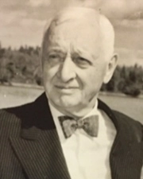

**Conrad Hal Waddington (8 November 1905 – 26 September 1975)**

Conrad Hal Waddington,  CBE , SCD , FRSwas a British developmental biologist, paleontologist, geneticist, embryologist and philosopher. Dr. Waddington won recognition in 1936 for his research into the substance] later identified as the DNA double helix.

<https://www.nytimes.com/1975/09/29/archives/dr-ch-waddington-69-dies-cast-light-on-lifes-development.html>

<https://royalsocietypublishing.org/doi/pdf/10.1098/rsbm.1977.0022>

Wrote book “Behind Appearance: A Study Of Relations Between Painting and Natural Sciences in This Century”

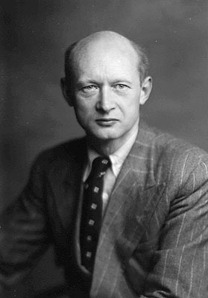

**Betty Royon** **(1913-2001)**

Betty Royon, Physicist. Graduated from Smith College and was known for her preservationist work.

[betty_royan_2_international_field_is_her_speciaioity_topika_kansas_jan_26_1967.pdf (thinkerslodgehistories.com)](https://www.thinkerslodgehistories.com/uploads/2/2/1/9/22191330/betty_royan_2_international_field_is_her_speciaioity_topika_kansas_jan_26_1967.pdf)

Betty Royon started in 1954 to work on making Pugwash, Nova Scotia a retreat for scientists, scholars, and people from all fields to exchange ideas.

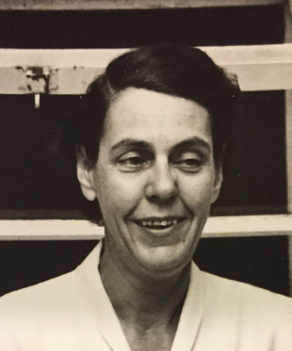

**Cecil Frank Powell (5 December 1903 – 9 August 1969)**

Cecil Frank Powell, FRS, Physicist. He developed the photographic method of studying nuclear processes. He is also known for discovering the subatomic particle – pion (pi-meson).

[Cecil Frank Powell, 1903-1969 (royalsocietypublishing.org)](https://royalsocietypublishing.org/doi/pdf/10.1098/rsbm.1971.0021)

The first conference established an executive, the Pugwash Continuing Committee, with Russell as Chairman, but

frequently absent, Powell in fact, as Deputy Chairman, always taking the Chair. He was elected Chairman in 1967. He also regularly took the Chair at the final and most difficult Plenary Session of each Pugwash Conference, at which statements were agreed upon.

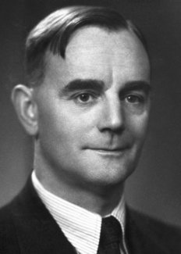

**Aleksandr Vasilevich Topchiev (July 27 (Aug. 9), 1907, Dec. 27, 1962)**

Aleksandr Vasilevich Topchiev, Chemist, Applied Chemistry. Was director of the Research Institute for Oil Chemistry of the Academy of Sciences. Permanent Scientific Secretary of the Academy of Sciences of the USSR

https://books.google.com/books?id=KwgAAAAAMBAJ&pg=PA8&dq=A.V.+Topchiev+1907&hl=en&sa=X&ved=2ahUKEwiswvjS4p71AhV4SjABHRGEANgQ6AF6BAgCEAI#v=onepage&q=A.V.%20Topchiev%201907&f=false

V. Topchiev attended the first Pugwash and only missed only one of the 10 of this series. “Firmly believed that the development of science had imposed on mankind the need for permanent, stable peace, and for making this peace possible and constructive. The Pugwash movement, dedicated to this idea, was close to his heart, and he invested in it as much of his energy and influence.”

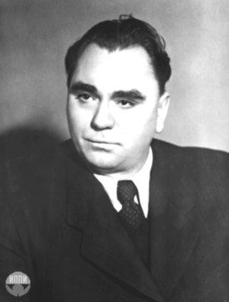

**Ann Moir - Assistant Editor of The Bulletin of American Scientists?**

**No Photo or biography**

**Patricia Lindop (21 June 1930 – 1 February 2018)**

**Patricia** Joyce Lindop FRCP, P**rofessor of radiation biology at the University of London**

<https://www.theguardian.com/science/2018/mar/02/patricia-lindop-obituary>

<https://celebratingamazingwomen.tumblr.com/search/patricia%20lindop>

**She was the organizer of at least 100 meetings where scientist discussed their nuclear disarmament campaign.** 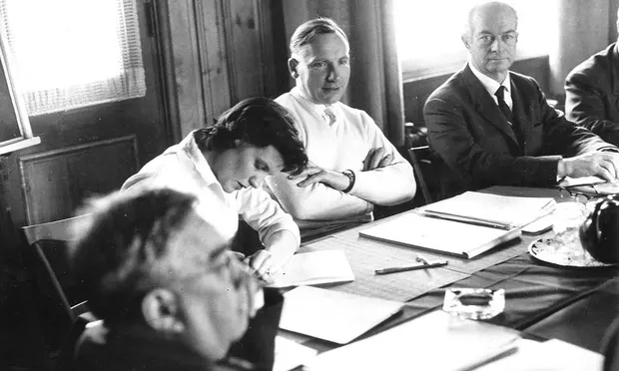

**Cyrias Ouellet, (January 19 , 1906 - April 14 , 1994)**

Cyrias Ouellet chemist , a pioneer in the development of chemical research in Quebec. Université Laval appointed him professor emeritus.

<https://fr.wikipedia.org/wiki/Cyrias_Ouellet>

<https://www.gf.org/fellows/all-fellows/cyrias-ouellet/>

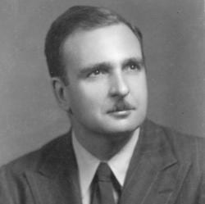

**Chou Pei-Yüan, (August 28, 1902 – November 24, 1993)**

Chou Pei-Yüan was a Chinese theoretical physicist and politician. He served as president of Peking University, and was an academician of the Chinese Academy of Sciences (CAS).[1]

<https://en.wikipedia.org/wiki/Zhou_Peiyuan>

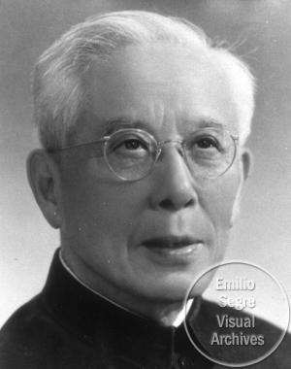

**Vladimir Pavlovich Pavlichenko**

Vladimir P. Pavlichenko, who since 1966 has been director of external relations in the United Nations Office of Public Information.

No official biography

[NARA - AAD - Display Full Records (archives.gov)](https://aad.archives.gov/aad/createpdf?rid=88430&dt=2476)

No Photo

**Carl Friedrich von Weizsäcker (1912-2007)**

Carl Friedrich von Weizsäcker (1912-2007) was a German theoretical physicist, and later philosopher, who worked on Nazi Germany’s atomic bomb program. Weizsäcker was one of the German scientists interned by the Allies’ [Alsos Mission](http://www.atomicheritage.org/history/alsos-mission) at Farm Hall in England.

https://www.atomicheritage.org/profile/carl-friedrich-von-weizs%C3%A4cker

Weizsäcker received the Max Planck Medal, the highest award of the German Physical Society, in 1957. That year he was one of the eighteen German scientists to sign the Göttingen Manifesto in opposition to arming West Germany’s army, the Bundeswehr, with tactical nuclear weapons.

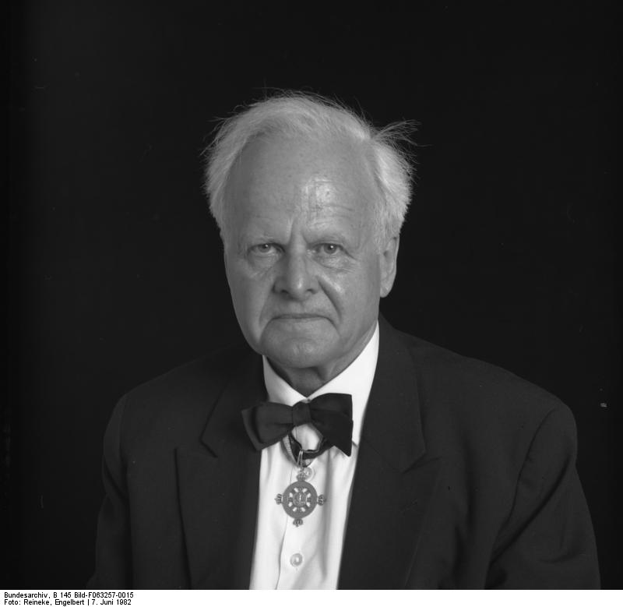

**Eugene Rabinowitch (1901–1973)**

Eugene Rabinowitch, was a Russian-American biophysicist and activist.

[Eugene Rabinowitch | Atomic Heritage Foundation](https://www.atomicheritage.org/profile/eugene-rabinowitch)

In October 1945, Eugene Rabinowitch and John Simpson Jr. wrote an article for Life magazine which argued that scientists were morally obligated to warn the public and policy makers about the dangers of nuclear weapons. That year he also founded the Bulletin of the Atomic Scientists with fellow physicists John Simpson and Hyman Goldsmith and was the magazine’s first editor. He edited the Bulletin until his death in 1973.

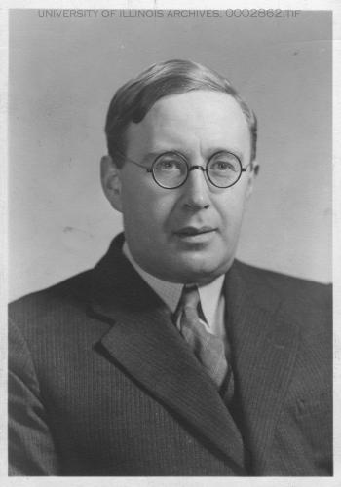

**Richard Sully Leghorn (7 February 1919 - January 15, 2018)**

Richard S. Leghorn, graduated from the Massachusetts Institute of Technology (MIT) in 1939 with a Bachelor of Science degree in physics and a reserve commission as an Army second lieutenant. Specializing in reconnaissance.

[Collection - Howard Gotlieb Archival Research Center (bu.edu)](http://archives.bu.edu/collections/collection?id=325593)

Leghorn participated in early Pugwash Conferences on Science and World Affairs and, in 1959- 60. During the 1950s and 1960s, Leghorn became deeply involved with public policy related to national security, arms control, and disarmament. He said in the 5 August 1955 issue of *U.S. News & World Report*, “And we might announce a start on construction of a reconnaissance earth satellite, the transmitted results from which we would be willing to turn over to a U.N. inspection agency.” As a consultant to President Eisenhower’s Assistant for Disarmament

Affairs during 1955-56, Leghorn was instrumental in formulating the “Open Skies” doctrine.

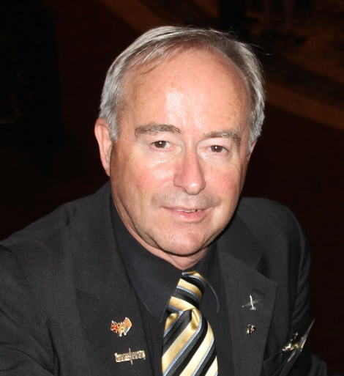

**Joseph Rotblat (4 November 1908 - 31 August 2005)**

Joseph Rotblat – MA, PhD, DSc, Physicist, Educated at the Free University of Poland and the University of Warsaw, Poland.

<https://www.nobelprize.org/prizes/peace/1995/rotblat/biographical/>

[Joseph Rotblat - Facts - NobelPrize.org](https://www.nobelprize.org/prizes/peace/1995/rotblat/facts/)

During the post-war period, Joseph Rotblat has done an enormous amount of work in the cause of peace, dialogue and disarmament through the Pugwash movement, with which he shared the Nobel Peace Prize in 1995.

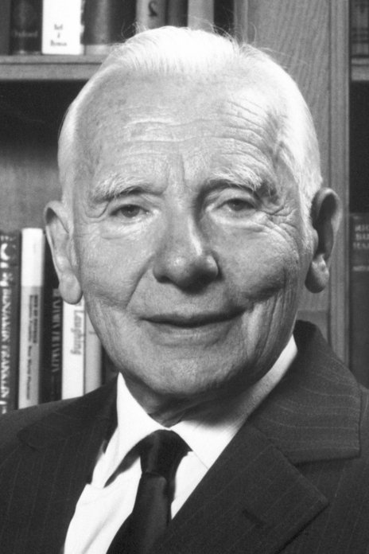

[Additional Resources – Pugwash Conferences on Science and World Affairs](https://pugwash.org/history/additional-resources/)